LED Laser Effect Light

User Manual

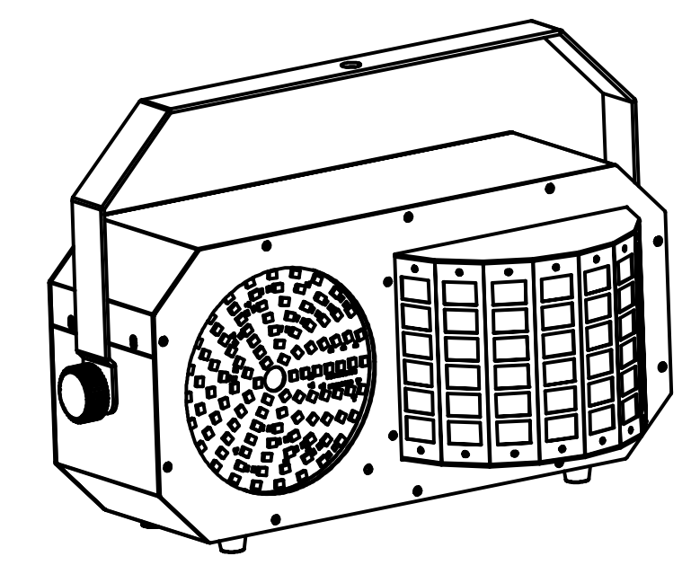

Please keep read this manual carefully for further use!

Content

Introduction---------------------------------------------------------------------------------- P2

Silkscreen symbol-------------------------------------------------------------------------- P3

Safety/specification-------------------------------------------------------------------------P4

LED Display operation----------------------------------------------------------------------P5

Channel ------------------------------------------------------------------------------------P6-7

Remote ---------------------------------------------------------------------------------------P8

DMX Connection and setting - --------------------------------------------------------P9

Product size，Installation--------------------------------------------------------------P10

Maintenance, warranty card----------------------------------------------------------P11

Thank you using our LED laser series products. This fixture is the latest new LED laser product.The product housing used Aluminum plastic material, beautiful appearance, with international advanced electronic control technology and excellent industrial design. Product effect more rich, colorful, and color is gorgeous because of installed high output light source.

This product applications widely, installation simple. Can widely used for small party, home party,small club,small stage and so on.

Spare part includes:
Parts | Qty | Units
Light | 1 | pcs
User manual | 1 | pcs
Power cable | 1 | pcs

Cautions
Before delivery, this device has passed strict inspection, Please follow the user manual strictly for operation, if this fixture is damaged by improper operation and mistake, the fixture will be out of warranty, and manufacture or dealer won’t be responsible for it. In case of any technology change in this manual,we won’t advise in further .



CAUTION!

Keep this device away from rain and moisture!

Unplug mains lead before opening the housing!

Warning!

Silkscreen symbol on light
Damages caused by the disregard of this user manual are not subject to warranty. The dealer will not accept liability for any resulting defects or problems.

Silkscreen symbol

-----------------------------------------------------------------------------CE certificate

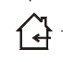

------------------------------------------------------------------------Only indoor using



---------------------------------------------------------------------------RoHS certificate

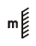
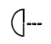
-------------------------------The minimum distance from lighted objects(meter)

--------------------------------------------------------------Max ambient Temp

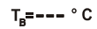
------------------------------------------------------------Max housing Temp


------------------------------------------------------------------------- Safety caution


----------------------------------------------------------------------Be careful of burn



----------------------------------------------------------------------Danger high voltage

-------Not allow installation directly on the surface of ordinary combustible materials

1. Safety instruction
- Once after received this product , please take and put carefully. And check cautiously that whether the product was damaged or not during the transportation, if yes, please not use this fixture and contact local dealers or manufacturers as soon as possible.
- The applicable temperature for the lighting is below 40°C. Do not use the lighting above the temperature.ta=40℃
- The fixture applicable widely, it must keeping clean, Please do not in overheat or dusty environment use the device. Do not touching Chemical liquid.
- Should be paid attention to the use of this product: fire, heat, electric shock, loss caused by severe or fatal injury, in electricity or to read the instructions before installation, follow the safety instruction and pay attention to the manual and warning signs on the equipment, if you have any other questions about how safe operating equipment, please contact the dealer or manufacturer as soon as possible.
- According to the procedures described in this operating instructions, please do not open by yourself. Any break, please contact professionals, and must by the professional and technical personnel for repair.
- Do not power in and open before installation. Let have a rest when continuous work for eight hours. It will longer the device using lift.
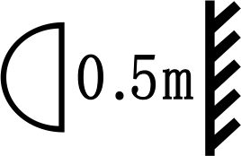
- Fixed installation, to prevent the strong vibration or impact of the device.
- The distance between the device and the projectile to keep at least 0.5 meter.

- Never look directly into the light source,as sensitive persons may suffer an epileptic shock(especially meant for epileptics)!
- When light output position of the device of dustproof glass breakage, cracks or other visible damage, user should replace the new glass to continue to use.

2. Installation
- When install this equipment please make sure there's no flammable surfaces (decorated things, etc) and minimum distance of 0.5M from the equipment to the flammable.

- The installation of the effect has to be built and constructed in a way that it can hold 10 times the weight and without any harming deformation.
- The installation must always be secured with a secondary safety attachment, e.g. an appropriate safety rope.Never stand directly below the device when mounting, removing or servicing the fixture.

3. Product Specification
Input voltage: AC100-240V 50/60Hz
Fuse: BGDP ￠5x20mm 250VAC T2A
Power consumption: 220V 50W
LED：2pcs 10W RGBW 4in1； Strobe: 105pcs 0.2W RGB 3in1
Laser: R: 100mw/650nm, G: 30mw/532nm,
Scanner: motor
Control mode: sound/auto/DMX/Master-slave/remote control
Working temp: 10-40℃
Net weight：5.2Kg; Gross weight: 6.5Kg
Inner packing: 51 X 29 X 29.5cm
Outer packing: 60 X 53 X 31.5cm (2pcs)

- LED Display operation
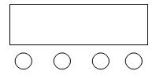
E
A.（MENU）
B．（UP）
C．(DOWN）
D．（ENTER）
E．LED DISPLAY
A B C D

 | MENU | UP/DOWN | Value | Function
1 | Addr | 1-512 | 1 | Address setting
2 | ChMd | 14Ch | 14Ch | 14 channel setting
2 | ChMd | 2Ch | 14Ch | 2 channel setting
3 | ShNd | Sh 1 | Sh 7 | Show 1，Led
3 | ShNd | Sh 2 | Sh 7 | Show 2, Strobe
3 | ShNd | Sh 3 | Sh 7 | Show 3, Laser
3 | ShNd | Sh 4 | Sh 7 | Show 4, Led+Laser
3 | ShNd | Sh 5 | Sh 7 | Show 5, Led+Strobe
3 | ShNd | Sh 6 | Sh 7 | Show 6, Laser+Strobe
3 | ShNd | Sh 7 | Sh 7 | Show 7，Led + Strobe + Laser
4 | SPEE | 0-100 | 90 | Sh 1-Sh 7 speed setting
5 | SLMD | MASt | MASt | Master mode
5 | SLMD | SLAV | MASt | Slave mode
6 | SoUn | ON/OFF | ON | Sound on/off
7 | SoSE | 0-100 | 90 | Sound sensitivity setting
8 | NodM | Prom | Prom | No DMX，Master mode
8 | NodM | BLAC | Prom | Standby
8 | NodM | HoLd | Prom | Holding last show
9 | LED | ON/OFF | ON | LED Display on/off
10 | Ver | V10 |  | Version
11 | Test |  |  | Lighting test

Instruction:
- No matter what working condition, when receiving the controller signal, it will enter the DMX control mode by auto.

- When several item in Master-slave mode, if more then 1pc item as the master, program will pick up one item as the master one randomly.

5. Channel
14CH mode
 |  | DMX-512Value 0-255 | Function
CH1 | Control Mode | 0-9 | No function
CH1 | Control Mode | 10-44 | Show 1，Led
CH1 | Control Mode | 45-79 | Show 2, Strobe
CH1 | Control Mode | 80-114 | Show 3, Laser
CH1 | Control Mode | 115-149 | Show 4, Led + Laser
CH1 | Control Mode | 150-184 | Show 5, Led + Strobe
CH1 | Control Mode | 185-219 | Show 6, Laser + Strobe
CH1 | Control Mode | 220-255 | Show 7, Led + Strobe + Laser
CH2 | RGBW color select (CH1<=9) | 0-9 | black-out
CH2 | RGBW color select (CH1<=9) | 10--198 | Choose colors（15 groups）, each 13 data for 1 color group
CH2 | RGBW color select (CH1<=9) | 199-225 | Color chase1（single color）from slow to fast
CH2 | RGBW color select (CH1<=9) | 226-255 | Color chase 2(multiple color）from slow to fast
CH2 | Sound active on/off（CH1>9） | 0-247 | Sound control off，Show 1-Show 7 from slow to fast
CH2 | Sound active on/off（CH1>9） | 248-255 | Sound control on，Show 1-Show 7
CH3 | Strobe LED | 0-9 | LED no strobe
CH3 | Strobe LED | 10-244 | LED strobe speed from slow to fast
CH3 | Strobe LED | 245-255 | LED strobe by sound
CH4 | LED Motor setting | 0-127 | LED motor position select
CH4 | LED Motor setting | 128-255 | LED motor scan speed from slow to fast
CH5 | Strobe LED Setting | 0-9 | Strobe LED off
CH5 | Strobe LED Setting | 10-255 | Strobe, LED chase effect select
CH6 | Strobe chase speed | 0-127 | No strobe, LED chase speed from slow to fast
CH6 | Strobe chase speed | 127-255 | With strobe, LED chase speed from slow to fast
CH7 | Laser color select | 0-9 | Laser off
CH7 | Laser color select | 10-127 | Laser color fixed
CH7 | Laser color select | 128-255 | Color chase speed from slow to fast
CH8 | Laser pattern select | 0-255 | Laser pattern select
CH9 | Laser pattern size | 0-63 | Choose patterns size
CH9 | Laser pattern size | 64-127 | From small to large,speed up rate
CH9 | Laser pattern size | 128-191 | From large to small,speed up rate
CH9 | Laser pattern size | 192-255 | Large – small – large, speed up rate
CH10 | Laser pattern rotation | 0-127 | Rotation angle select
CH10 | Laser pattern rotation | 128-191 | positive rotation speed
CH10 | Laser pattern rotation | 192-255 | Inverted rotation speed
CH11 | Laser pattern pan position | 0-127 | Horizontal position
CH11 | Laser pattern pan position | 128-255 | Horizontal move,speed up rate
CH12 | Laser pattern tilt position | 0-127 | Choose vertical position
CH12 | Laser pattern tilt position | 128-255 | Vertical move,speed up rate
CH13 | Laser scan track choose | 0-255 | Track choose
CH14 | Laser track scan speed choose | 0-255 | Laser track scan speed from slow to fast

2.2CH mode
 |  | DMX-512 Value 0-255 | Function
CH1 | Show mode | 0-9 | No function
CH1 | Show mode | 10-44 | Show 1，Led
CH1 | Show mode | 45-79 | Show 2, Strobe
CH1 | Show mode | 80-114 | Show 3, Laser
CH1 | Show mode | 115-149 | Show 4, Led + Laser
CH1 | Show mode | 150-184 | Show 5, Led + Strobe
CH1 | Show mode | 185-219 | Show 6, Laser + Strobe
CH1 | Show mode | 220-255 | Show 7, Led + Strobe + Laser
CH2 | Show speed/Sound active | 0-247 | Show 1-Show 7 speed from slow to fast
CH2 | Show speed/Sound active | 248-255 | Show 1-Show 7 Sound active

6.Remote
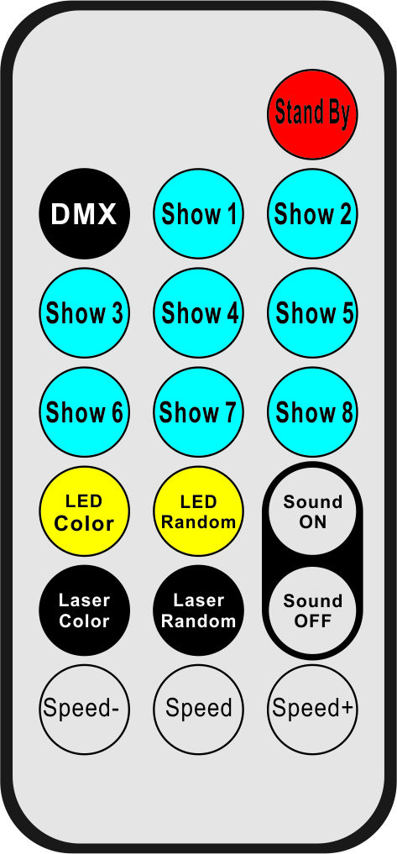
6
7
11
10
18
19
14
17
16
15
1
2
5
8
3
4
9
12
13

Number | Button | Function
1 | Stand By | Stand by
2 | DMX | Hold on
3-10 | Show 1-Show 8 | Show1-Show7 (Show 8 hold on)
11 | LED Color | LED color select
12 | LED Random | LED color randomly
13 | Sound ON | Sound on
14 | Laser Color | Laser color select
15 | Laser Random | Laser color randomly
16 | Sound OFF | Sound off
17 | Speed - | Show 1 - Show 7 speed down
18 | Speed | Show 1 - Show 7 speed default
19 | Speed+ | Show 1 - Show 7 speed up

7. DMX-512 connection

3 Pin DMX output 3 Pin DMX input

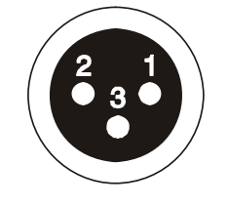
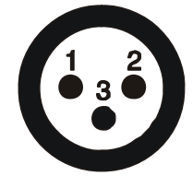

1 Ground 2 Signal - 3 Signal +

14ch for example
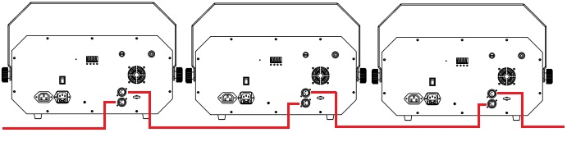
DMX in
DMX out
First one add 001 Second one add 015 Third one add 029
8. DMX address setting
Each fixture must set a specific starting address. When receiving signal, fixture will receive channel control signals of this address from the DMX controller.
For easy to use, the user can set the same address for several fixtures , also can set up a unique address for every device.
If you set the same address for all fixtures, all the fixtures will receive from the same DMX channels signal. All connecting fixtures are jointly controlled, controller can't separately control a device.
If you set a different address for each fixture, each fixture will receive unique signal and can be controlled by DMX controller separately.
This fixture has 14 channels.you should set the starting address of the first unit to 1, the second unit to 15(1*14 + 1), the third unit to 29(2*14+ 1), and so on.


9. Installation
1 Clamp
2 Handle
When install this equipment please make sure there's no flammable surfaces (decorated things, etc) within at least 2.5M and maintain minimum distance of 0.5M from the equipment to the walls.

Please make sure that there's no other equipment or decorating materials obstructed the exhaust fan and the vent-pipe.

Products should be install immobility.

In case of safety, it's very important that to connect the earth with line.

10.Product size
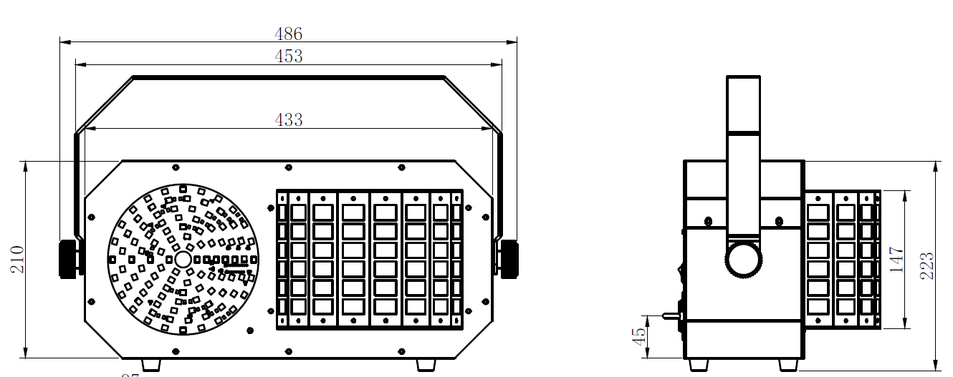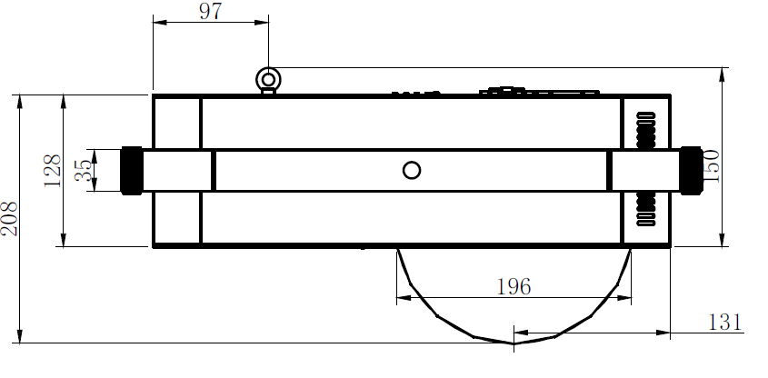
Declaration
Cleaning and maintenance

Cleaning should be performed every 15-day period, by using a sponge which is dipped with alcohol, rather than wet cloth or other chemical liquid, to clean the mirror.
Cut off power before cleaning and maintenance!
CAUTION

Attention

Do not see directly light source when open the light, and make sure power off before do any installation or maintenance.

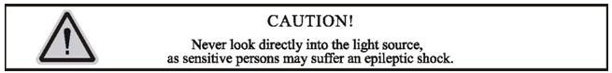
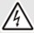 Wires connection must be professional person!
CAUTION

Warranty Card
This product is made of high-brightness transistor. We will provide 1 year warranty under the condition that user has operated the light normally and lifetime service. We won't provide warranty if the damage is caused by artificial or force majeure event. Cost of fittings should be charged by user if product need maintenance after 1 year .Please cut this warranty card and shipped it along with the product to our factory when applying for warranty.
Product： Purchasing date： Code of invoice：
Warranty date: From To
User’s name： Add：
Company： Tel：

